**COATL mmWave RADAR:**

**Functional Decomposition**

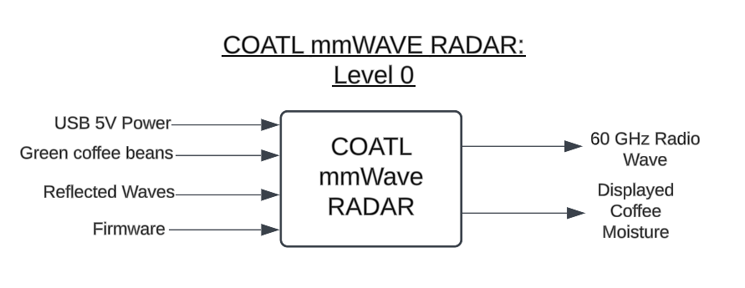

| *Module* | COATL mmWave RADAR |
| --- | --- |
| *Inputs* |  |
| *Outputs* |  |
| *Functionality* |  |

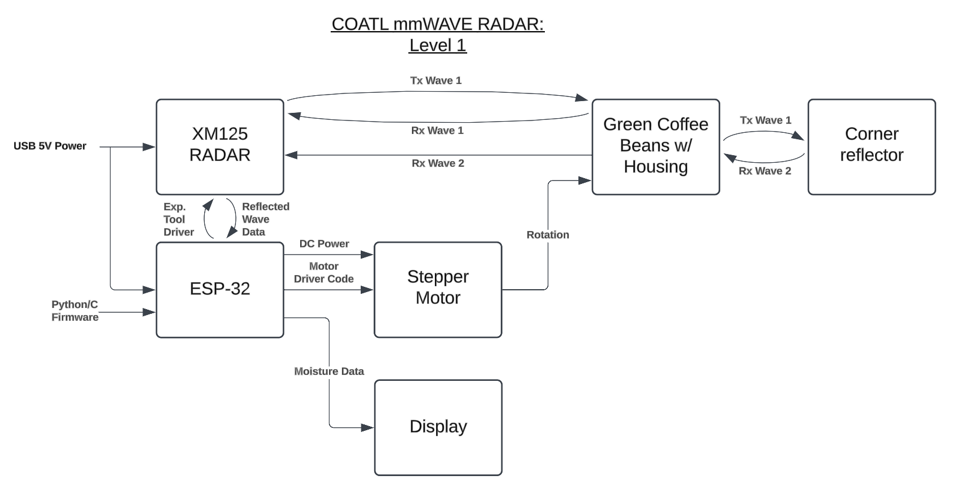

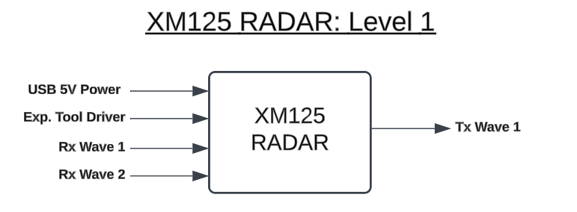

| *Module* | XM125 RADAR |
| --- | --- |
| *Inputs* |  |
| *Outputs* |  |
| *Functionality* |  |

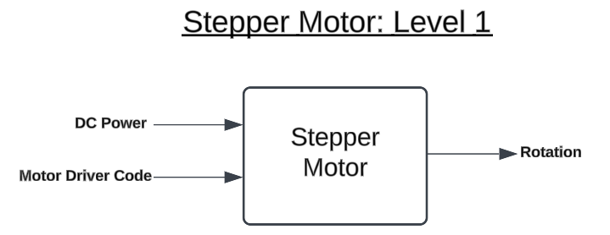

| *Module* | Stepper Motor |
| --- | --- |
| *Inputs* |  |
| *Outputs* |  |
| *Functionality* |  |

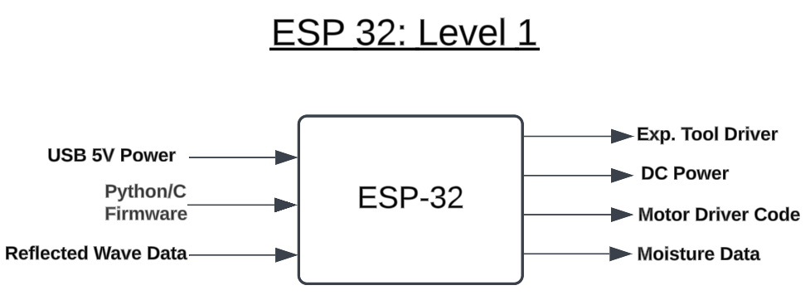

| *Module* | ESP 32 |
| --- | --- |
| *Inputs* |  |
| *Outputs* |  |
| *Functionality* |  |

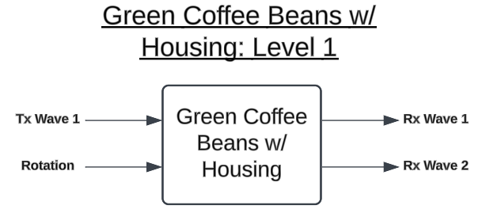

| *Module* | Green Coffee Beans w/ Housing |
| --- | --- |
| *Inputs* |  |
| *Outputs* |  |
| *Functionality* |  |

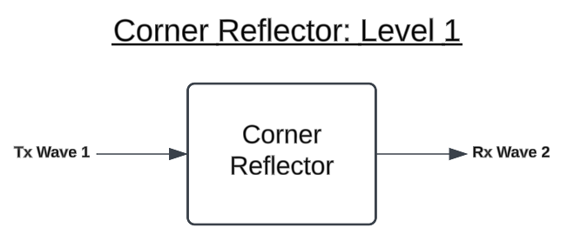

| *Module* | Corner Reflector |
| --- | --- |
| *Inputs* |  |
| *Outputs* |  |
| *Functionality* |  |

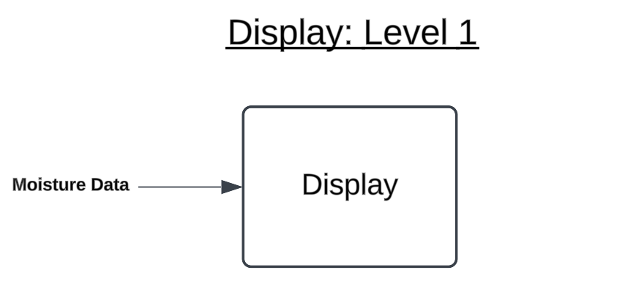

| *Module* | Display |
| --- | --- |
| *Inputs* |  |
| *Outputs* |  |
| *Functionality* |  |